Searching for real estate sale(s) information in Cedar County, Iowa.

Go to the following website: http://cedar.iowaassessors.com/

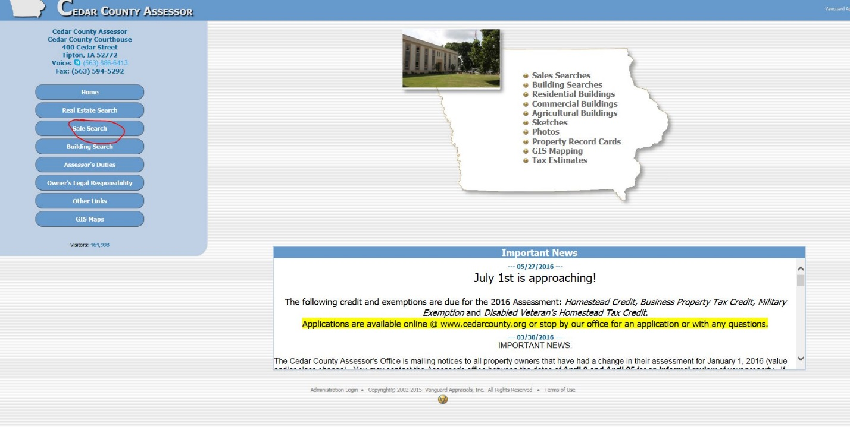

Click on “sale search” on the left side of the page.

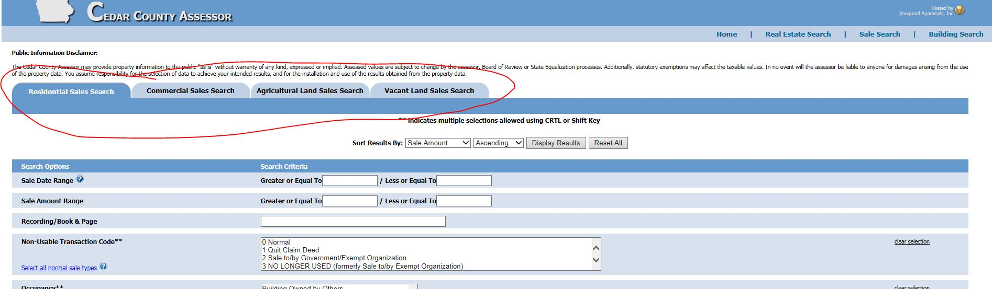

Click on the blue tab for the type of sale(s) information you are seeking. You can also sort the results by various criteria.
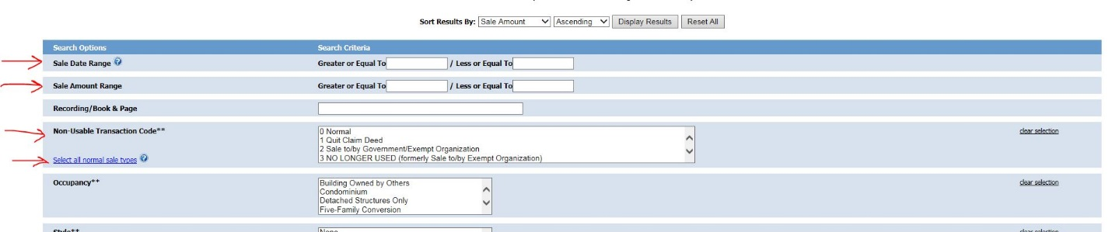

Enter the parameters you are using. (Sale date/s, price range, etc.). There is an option for arm’s length transactions or non-arms-length transactions. Additional criteria depending upon the type of sale(s) information you are seeking continues down the page.

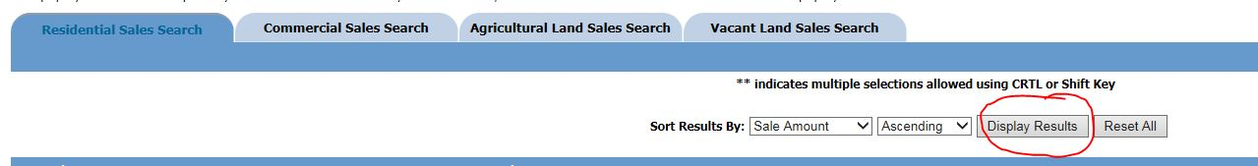

Once your required sales parameters are entered click on ‘Display results’ at the top of the page. This will display the results within the parameters entered.

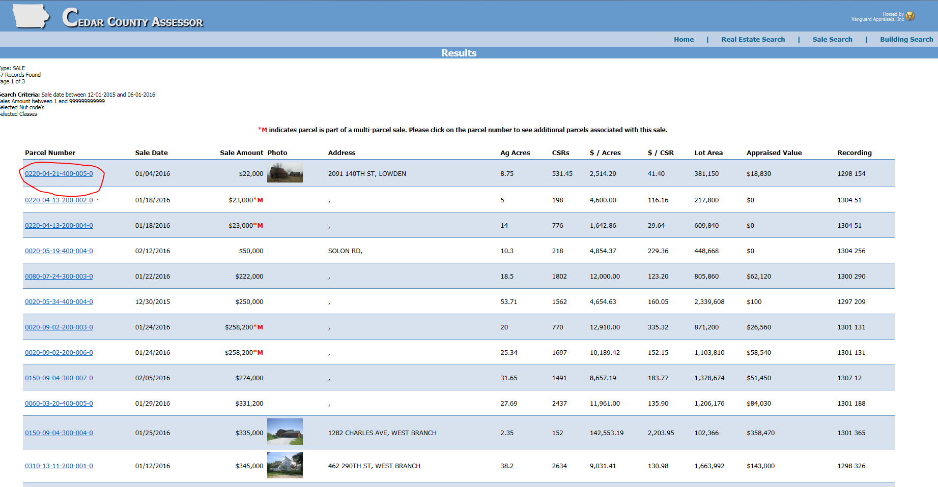
The displayed results will appears similar to this. Clicking on the parcel number (blue type, left side of screen will open to that specific parcel number and can provide additional information. (Maps, etc.)
General notes:
Sometimes less is more; greater range(s) or less detailed criteria may render more results.
The Cedar County Assessor’s Office provided property information to the public “as is” without warranty or guarantee, expressed or implied. A good faith effort has been made to provide the most accurate data possible. However, error or omissions are possible, and the user is hereby advised of that possibility. In no event will the Assessor, Cedar County, its officers, employees or agents be liable to anyone for damages arising from the use of the property data.

